Title
Impact of extracorporeal blood flow targets on celiac trunk blood flow during abdominal normothermic regional perfusion

First and Presenting author
Marta Velia Antonini MSc m.antonini@unibo.it
Department of Medical and Surgical Sciences (DIMEC), University of Bologna, Bologna, Italy
Intensive Care Unit, Bufalini Hospital, AUSL della Romagna, Cesena, Italy

Co-authors
Lorenzo Viola MD Azienda Ospedaliera S.Croce e Carle, Anesthesia and Intensive Care Unit, Cuneo, Italy
Mattia Carnelli MD Intensive Care Unit, Bufalini Hospital, AUSL della Romagna, Cesena, Italy
Giuliano Bolondi MD Intensive Care Unit, Ospedale Civile di Baggiovara, AOU Modena, Modena, Italy
Luca Bastia MD Intensive Care Unit, Bufalini Hospital, AUSL della Romagna, Cesena, Italy
Giampaolo Orsolini MD Intensive Care Unit, Bufalini Hospital, AUSL della Romagna, Cesena, Italy
Luca Gobbi MD Intensive Care Unit, Bufalini Hospital, AUSL della Romagna, Cesena, Italy
Vanni Agnoletti Prof Intensive Care Unit, Bufalini Hospital, AUSL della Romagna, Cesena, Italy
Alessandro Circelli MD Intensive Care Unit, Bufalini Hospital, AUSL della Romagna, Cesena, Italy

Introduction
The target extracorporeal blood flow (EBF) to be provided during abdominal-normothermic regional perfusion (A-NRP) in donors undergoing circulatory determination of death (DCDDs) is still debated. The ideal EBF should support an appropriate oxygen delivery (DO₂), while preventing hyperperfusion related end-organs damage. Moreover, it should be effectively and safely achieved and maintained, without an excessive need for volume replacement. Lastly, in the setting of endovascular balloon occlusion of the aorta (EBOA), the retrograde EBF should not be high enough to impair regionalization effectiveness.
To evaluate the impact of variable EBF on restoring perfusion, we measured the blood flow through the celiac trunk (CT_{BF}) during A-NRP.

Methods
In this pilot study, we assessed CT_{BF} in six controlled DCDDs. CT was visualized antemortem with transesophageal ultrasound (TEU). The use of TEU is our standard of practice to guide cannulation, and endovascular balloon occluder positioning/inflation.
The TEU probe was advanced to transgastric position, with the abdominal aorta in short axis (figure A-B). If normal anatomy, CT appeared as the first major branch. CT diameter was measured before withdrawal of life sustaining measures.
Being a cylinder-like structure, CT cross sectional area (CSA_{CT}) was calculated as:
CSA_{CT} = [(CT diameter)/2]² x π
The velocity of CT_{BF} over time was visualized by pulsed-wave doppler, and its curve traced to obtain velocity-time integral (VTI_{CT}). VTI_{CT} was multiplied by CSA_{CT} to achieve systolic CT_{BF}, which was multiplied by antemortem heart rate to obtain CT_{BF} in L/minute.
During NRP, post-mortem, a continuous EBF is generated by the circuit pump, so velocity/time profile becomes linear. The VTI_{CT} was assessed over one second and multiplied by 60, to obtain CT_{BF} in L/minute (figure). This measurement was repeated with EBF set at 40% (CT_{BF40}), 60% (CT_{BF60}), and 80% (CT_{BF80}) of the predicted cardiac index (CI) commonly used during normothermic cardiopulmonary bypass in adults (2.4 L/min/m² multiplied by body surface area).

Results
Results of CT_{BF} measurements during NRP, and their relationship with antemortem CT_{BF}, are displayed in the table. CI_{40%} was never enough to reproduce antemortem CT_{BF}. CI_{60%} was adequate in half of the donors, specifically if BSA < 2 m₂. CI_{80%} was above or largely above antemortem CT_{BF} in all but one donor.

Conclusions
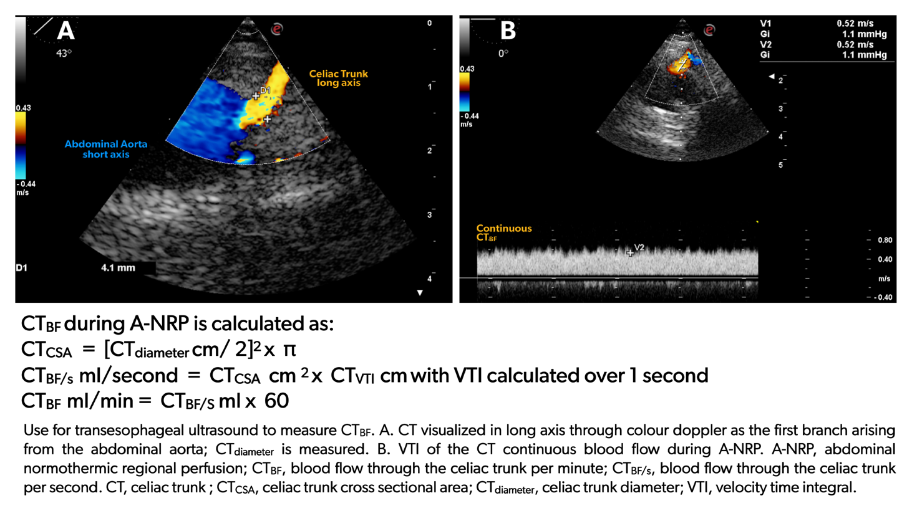
Targeting an optimal, donor adapted, EBF during A-NRP could improve the results of organ recovery form DCDDs. Too high EBF may be harmful for splanchnic circulation, and difficult to be maintained without an excessive volume expansion. Too low EBF might impair organ perfusion. Implementing CT_{BF} assessment in larger cohorts of DCDDs may assist in defining this goal.
